CaterConnect: An Agentic AI-Powered Catering Booking
and Surplus Food Redistribution System

A Mini Project Report Submitted in the partial fulfillment of the requirements for the award of the degree of

BACHELOR OF TECHNOLOGY

In
DEPARTMENT OF COMPUTER SCIENCE ENGINNERING
By
- Divya Sree – 2420030416 (Team Lead)
Y. Paavana Pranavasri – 2420030554
B. Yaswanth – 2420030392

Under the Esteemed Guidance of

K. Venkateswari





K L (Deemed to be) University
DEPARTMENT OF COMPUTER SCIENCE ENGINEERING
Or
DEPARTMENT OF COMPUTER SCIENCE AND INFORMATION TECHNOLOGY

DECLARATION

The Mini Project Report entitled “CaterConnect: An Agentic AI-Powered Catering Booking and Surplus Food Redistribution System “is a record of Bonafide work of A. Divya Sree – 2420030416, Y. Paavana Pranavasri – 2420030554, B. Yaswanth – 2420030392 submitted in partial fulfillment for the award of B. Tech in Computer Science and Engineering to the K L University. The results embodied in this report have not been copied from any other departments/University/Institute.

- Divya Sree – 2420030416
Y. Paavana Pranavasri – 2420030554
B. Yaswanth – 2420030392

K L (Deemed to be) University
DEPARTMENT OF COMPUTER SCIENCE ENGINEERING
Or
DEPARTMENT OF COMPUTER SCIENCE AND INFORMATION TECHNOLOGY
CERTIFICATE

This is certify that the mini project based report entitled “CaterConnect: An Agentic AI-Powered Catering Booking and Surplus Food Redistribution System” is a bonafide work done and submitted by A. Divya Sree – 2420030416, Y. Paavana Pranavasri – 2420030554, B. Yaswanth – 2420030392 in partial fulfillment of the requirements for the award of the degree of BACHELOR OF TECHNOLOGY in Department of Computer Science Engineering, K L (Deemed to be University), during the academic year 2026-2027.

Signature of the Course Co-ordinator Signature of HOD

ACKNOWLEDGEMENT

The success in this project would not have been possible but for the timely help and guidance rendered by many people. Our wish to express my sincere thanks to all those who has assisted us in one way or the other for the completion of my project.

Our greatest appreciation to my guide, K. Venkateswari, Department of Computer Science which cannot be expressed in words for his/her tremendous support, encouragement and guidance for this project.

We express our gratitude to Dr. P.Venkateshwar Sir (CSE)/Dr. Kaja Shareef Sir (CSIT), Head of the Department for Computer Science Engineering/ Department for Computer Science and Information Technology for providing us with adequate facilities, ways and means by which we are able to complete this project-based Lab.

We thank all the members of teaching and non-teaching staff members, and also who have assisted me directly or indirectly for successful completion of this project. Finally, I sincerely thank my parents, friends and classmates for their kind help and cooperation during my work.

- Divya Sree – 2420030416
Y. Paavana Pranavasri – 2420030554
B. Yaswanth – 2420030392

TABLE OF CONTENTS

S.No. | Contents | Page no.
1. | Abstract
2. | Introduction
3. | Literature survey
4. | Problem Statement and Objectives
5. | Hardware and Software requirements
6. | Implementation
7. | Results & Discussion
8. | Conclusion & Future Scope
9. | References

- ABSTRACT

CaterConnect is a web-based catering booking and surplus food redistribution system designed to simplify catering arrangements and support the responsible use of surplus food. The system provides separate interfaces for customers, caterers, and administrators to support their respective activities. Customers can enter their event requirements, explore suitable catering options, compare menus and pricing, and proceed with booking. Agentic AI-supported recommendations help users identify options according to their stated requirements. The system follows a Service-Oriented Architecture (SOA), separating functions such as caterer management, menu management, availability, booking, notifications, surplus food management, and organization matching into distinct service responsibilities. It also provides a workflow for recording surplus food and connecting it with suitable recipient organizations. The project uses structured datasets, including Caterers.csv, menu_pricing.csv, food_surplus.csv, and organizations.csv, to support the relevant application workflows. By bringing catering discovery, booking coordination, and surplus food redistribution into one platform, CaterConnect aims to reduce manual effort, improve coordination among users, and encourage food-sharing practices. The project demonstrates how AI-supported recommendations and service-based design can be combined to address practical catering management needs. Its current implementation provides a foundation for further improvements in recommendation evaluation, reliability, notifications, and real-world deployment.
Team Name: CaterConnect
Team Logo: KL University logo (as shown on the title page).

Team Members:
- A. Divya Sree – 2420030416 – Team Lead
- Y. Paavana Pranavasri – 2420030554 – Team Member
- B. Yaswanth – 2420030392 – Team Member

- INTRODUCTION

Catering is an important part of weddings, birthday parties, corporate meetings, college events, and other social functions. Selecting a suitable caterer requires customers to consider several factors, including event type, guest count, menu preferences, budget, and availability. When this information is spread across different providers, the process of comparing options and managing bookings can become time-consuming. At the same time, food prepared for events may remain unused, while nearby organizations and communities may need food support.
CaterConnect is developed to address these challenges through a unified web-based platform. It provides role-based access for customers, caterers, and administrators. Customers can explore catering options and receive AI-supported recommendations based on their requirements. Caterers can manage their profiles, menus, availability, and booking activities, while administrators can oversee platform activities.
The project follows a Service-Oriented Architecture (SOA), in which different responsibilities are separated into service modules. It also includes a surplus-food redistribution workflow that connects available surplus food with suitable recipient organizations. The following sections describe related systems, the problem statement, objectives, requirements, implementation, results, and future enhancements.

- LITERATURE SURVEY
The following related studies are identified in the Project Review-1 presentation. They cover conversational recommendation, online catering booking, and food-donation allocation. Together, they provide the background for CaterConnect’s combination of AI-supported catering selection, SOA-based booking services, and surplus-food redistribution.
1. Iovine, Narducci & Semeraro (2020) – “Conversational Recommender Systems and Natural Language: A Study through the ConveRSE Framework.”
The ConveRSE framework studies conversational recommendation through natural language, buttons, or a combination of interaction modes. It shows how interactive systems can collect user preferences and provide personalized recommendations. The study supports CaterConnect’s conversational requirement-gathering approach. It also identifies challenges such as cold-start and dialogue disambiguation, indicating the need for domain-specific integration.
2. Letchumanan & Mat Nawi (2024) – “The Development of VGL Catering Booking System: VGL Cate using Object-Oriented Approach.”
This work describes a web-based catering booking system developed using an object-oriented approach and the Waterfall model. Its features include customer login, food ordering, date reservation, online deposit or payment, booking management, and data management. It demonstrates how online booking can simplify coordination for customers and caterers. Its stated limitation is its focus on a single provider, without Agentic AI recommendations, multi-caterer comparison, or surplus-food redistribution.
3. Dalal (2022) – “Food Donation Management under Supply and Demand Uncertainties: A Robust Optimization Approach.”
This study applies robust optimization to donor selection, beneficiary allocation, and food-donation flows under uncertain supply and demand. It demonstrates the value of computational methods for improving donation allocation and resource utilization. The work focuses on food-donation allocation rather than a complete catering application. It does not combine AI-assisted catering booking, automated notifications, and SOA services.

4. Problem Statement and Objectives

Problem Statement:
Customers face difficulties in identifying and comparing suitable catering services, while surplus food from events may not reach organizations that need it.
Problem Description:
Traditional catering arrangements can involve manual searching, price comparisons, availability checks, and communication with multiple providers. Separately, the lack of a coordinated digital workflow can make surplus-food redistribution more difficult.
Objectives:
- Develop a unified platform for catering discovery and booking management.
- Provide AI-supported recommendations based on customer requirements.
- Enable customers to explore caterers, menus, pricing, and availability.
- Provide role-based workflows for customers, caterers, and administrators.
- Organize application responsibilities using a Service-Oriented Architecture.
- Enable surplus-food listings and matching with suitable recipient organizations.
- Improve coordination, usability, and transparency across the platform.
- Establish a foundation for future evaluation and real-world deployment.

5.HARDWARE AND SOFTWARE REQUIREMENTS
Hardware Requirements:
- Processor: Intel Core i3 or equivalent and above
- RAM: Minimum 4 GB; 8 GB recommended
- Storage: At least 10 GB of available space
- Display: Standard monitor or laptop display
- Network: Internet connection for accessing the application and any external integrations
Software Requirements:
- Operating System: Windows, Linux, or another supported operating system
- Frontend: Web-based user interface; the specific frontend framework/language is not identified in the Project Review-1 PPT.
- Backend: Independent SOA services exposed through APIs; the specific backend language and framework are not identified in the Project Review-1 PPT.
- Architecture: Service-Oriented Architecture (SOA)
- Data files: Caterers.csv, menu_pricing.csv, food_surplus.csv, organizations.csv
- Browser: Google Chrome or another modern web browser
- Development tools: To be updated with the actual editor, runtime, libraries, database, and tools used by the team.

6.IMPLEMENTATION
- Frontend: A unified web interface is intended for customers, caterers, NGOs, pickup partners, and administrators. Customers submit event requirements in natural language and can review recommended catering options. Caterers manage profiles, menus, packages, and availability. NGOs manage their profiles and food requirements.
- Backend: The system is organized as independent SOA services. The catering side contains Catering, Menu, Availability, Booking, Payment, and Notification services. The redistribution side contains Food Surplus, NGO, Donation, and Pickup services. Each service handles a separate business responsibility and communicates through APIs.
- API Integration: The Agentic AI layer interprets user requirements, extracts and normalizes entities, analyzes context, and selects suitable services. It uses structured and historical data for contextual matching and recommendations. Service responses support booking decisions and the surplus-food workflow.

1. Frontend: The review presentation describes a web-based interface for the different user roles. The exact source filenames and frontend framework are not specified in the PPT and should be entered from the implemented project.
- Customer interface: accepts natural-language event requirements such as event type, guest count, cuisine, date, and budget.
- Caterer interface: supports caterer profiles, menu/package information, and availability management.
- NGO interface: supports NGO profiles, food requirements, donation acceptance, and pickup coordination.
- Administrator and analytics interface: intended to oversee activities and display booking summaries, surplus food rescued, NGO impact, sustainability metrics, and reports.
2. Backend – SOA Services: The architecture diagram in the review PPT identifies the following independent service modules.
- Catering, Menu, Availability, Booking, Payment, and Notification services manage the catering booking lifecycle.
Food Surplus, NGO, Donation, and Pickup services manage surplus registration, recipient matching, donation requests, acceptance, and collection.
- API Integration and Agentic AI: The AI workflow includes input understanding and intent detection, entity extraction with min–max normalization, text/data normalization, requirement and context analysis, contextual matching, recommendation, and booking/redistribution decision-making.
---integration code files

7.RESULTS & DISCUSSION
The Project Review-1 PPT presents the proposed system architecture and workflows rather than completed website screenshots. The architecture diagram below shows how users, AI processing, SOA services, booking, and surplus-food redistribution are connected. Add screenshots of the running application here when available.
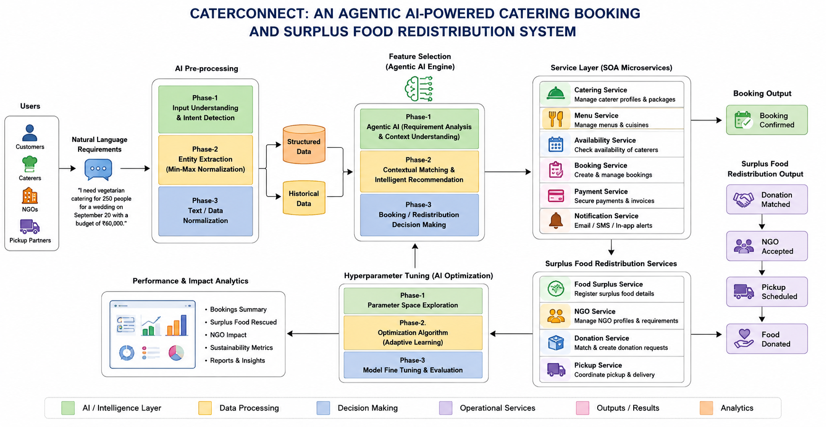
Figure 1: CaterConnect system architecture and end-to-end workflow (adapted from Project Review-1, slide 7).
The diagram shows natural-language input passing through AI pre-processing and requirement analysis before invoking the relevant SOA services. Booking requests proceed through catering services, while surplus food is registered, matched with NGOs, accepted, and scheduled for pickup. Analytics summarize bookings and food-rescue impact.

8.CONCLUSION & FUTURE SCOPE
CaterConnect proposes a unified platform for catering discovery and booking together with surplus-food redistribution. The objectives defined in the review include conversational requirement understanding, personalized caterer and menu recommendations, independent SOA services, role-based workflows, and matching surplus food with suitable NGOs. The architecture in the review PPT maps these requirements to dedicated catering and redistribution services. The project therefore establishes a clear service-based design for addressing both catering coordination and food wastage.

Near-term: Complete and test the customer, caterer, NGO, and administrator interfaces; connect all SOA services through APIs; and validate booking, payment, notification, donation acceptance, and pickup workflows.\nMedium-term: Evaluate recommendation quality and matching accuracy using structured and historical data; improve model tuning; and measure booking summaries, quantity of food rescued, NGO impact, and sustainability metrics.\nLong-term: Extend the platform for real-world deployment, improve reliability and scalability, support more recipient and pickup partners, and refine automated coordination and reporting.

9.REFERENCES

1. Iovine, Narducci & Semeraro (2020). “Conversational Recommender Systems and Natural Language: A Study through the ConveRSE Framework.”
2. Letchumanan & Mat Nawi (2024). “The Development of VGL Catering Booking System: VGL Cate using Object-Oriented Approach.”
3. Dalal (2022). “Food Donation Management under Supply and Demand Uncertainties: A Robust Optimization Approach.”
4. Project Review-1 presentation: “CaterConnect: An Agentic AI-Powered Catering Booking and Surplus Food Redistribution System,” 18 August 2026.
5. The Project Review-1 PPT does not provide publication DOI/URLs or additional website references. Add the verified source links before final submission.

